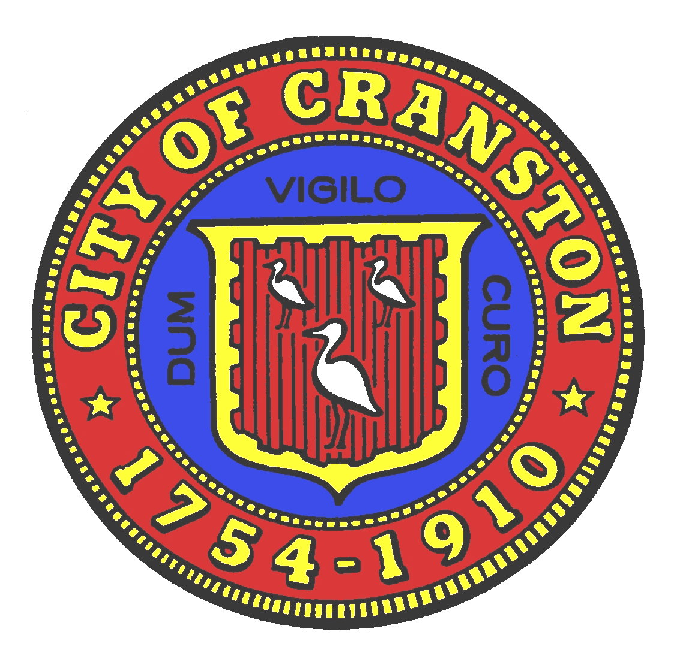
Allan W. Fung

Mayor

Michael E. Smith
President

Jason M. Pezzullo, AICP
Planning Director

Ken Mason, P.E.
Robert Strom
Frederick Vincent
Kathleen Lanphear
Ann Marie Maccarone
Joseph Morales
Robert DiStefano
Robert Coupe

CITY PLAN COMMISSION

Cranston City Hall
869 Park Avenue, Cranston, RI 02910

AGENDA

JOINT SITE VISIT OF THE CITY PLAN COMMISSION AND THE CRANSTON CITY COUNCIL

Who: City Plan Commission, the Cranston City Council, any interested members of the public
Where: 1500 Oaklawn Avenue parking area
When: Saturday, February 22nd, 2020 – 9:00AM
What: Applicant (Deborah Clift, 529 Reservoir Avenue) has proposed to demolish all existing structures to redevelop the site as a conforming multi-use commercial project. The proposal includes a Comprehensive Plan amendment and zone change from Single-Family Residential to Highway Commercial on the north eastern and eastern portion of the site (depicted below). The subject parcels are: 0 Catherine Street, 240, 250 and 254 Bateman Avenue. AP 15, Lots 492 through 498, 533, 534, 882 & 1619.

If you have any questions or concerns, please contact Jason Pezzullo at 780-3222 or via email.

Telephone: (401) 461-1000 x 3136 Fax: (401) 780-3171 jpezzullo@cranstonri.org

